

**A SYNOPSIS ON**

**COVID - 19 IMPACT ON AIRPORT TRAFFIC**

**UNDER THE GUIDANCE OF**

**AISHWARYA SAXENA**

 

|  |  |  |
| --- | --- | --- |
| Sr. No. | Topic | Page No. |
| 1 | Introduction | 3 |
| 2 | Objective | 3 |
| 3 | Background | 3 |
| 4 | Hardware and Software Requirements | 4-5 |
| 5 | Coding | 5-10 |
| 6 | Output Screenshots | 11-21 |
| 7 | Future Scope | 22 |
| 8 | Conclusion | 22 |
| 9 | Bibliography | 23 |

INDEX

INTRODUCTION

The end of a decade of sustained increase in global passenger traffic was highlighted last year. In the second quarter of 2020, the ongoing COVID-19 pandemic brought airports around the world to a halt, resulting in traffic — and income —losses in all regions. While several countries have gradually reopened various areas of their economies since then, numerous states have been hit by successive waves of viruses, prompting many jurisdictions to re-impose partial lockdowns.

This project- COVID - 19 IMPACT ON AIRPORT TRAFFIC, analyses the airport traffic and predicts 2021 circumstances. I have used 80% data of year 2021 into training and 20% data for testing. This of model of mine gives 99.89% accuracy with DecisionTreeClassifier. It is function to measure the quality of split

OBJECTIVE

The current COVID-19 crisis has forced aviation industry to adjust quickly to adapt to the situation. With many aircraft grounded due to significant decrease of passenger demand, the airlines try to find alternate, quick and effective measures to be able to survive as the crisis continue worldwide. In reaction to the current situation, the International Air Transport Association (IATA) has published its press release, which states that every government have important role to support the aviation industry especially in the financial sector such as direct financial support, loans and tax relief. IATA also mentions that currently, over 2.7 million-airline job is at risk. The objective of this machine learning project is to analyses and study the impact of covid 19 on airport traffic. It will help us to predict and analyses the data which will help grow their business again.

BACKGROUND

**Impact of COVID-19 on airport traffic dataset**

This dataset shows traffic to and from the Airport as a Percentage of the Traffic volume during the baseline period. The baseline period used for computing this metric is from 2016 to 2021. Dataset link:- <https://ansperformance.eu/data/>

Different Algorithms Used:-

Linear Regression, Data Wrangling, Data Cleaning, Exploratory Data Analysis,

Different libraries used:

import numpy as np

import pandas as pd

import matplotlib.pyplot as plt

import seaborn as sns

from sorted_months_weekdays import *

from sort_dataframeby_monthorweek import * #for sorting based on month

from sklearn.preprocessing import LabelEncoder

from sklearn.model_selection import train_test_split

from sklearn.preprocessing import StandardScaler

from sklearn.tree import DecisionTreeClassifier

**HARDWARE AND SOFTWARE REQUIREMENTS**

|  |  |
| --- | --- |
| SOFTWARE TOOLS | MINIMUM REQUIREMENTS |
| Platform | Windows, Linux or MacOS |
| Operating System | Windows, Linux or MacOS |
| Technology | Windows, Linux or MacOS |
| Scripting | Python |
| IDE | PyCharm |

|  |  |
| --- | --- |
| HARDWARE TOOLS | MINIMUM REQUIREMNTS |
| Processor | AMD or above |
| Hard Disk | 8GB |
| RAM | 8GB |
| Monitor | 17”Coloured |
| Mouse | Optical |
| Keyboard | 122 K |

CODING

#!/usr/bin/env python

# coding: utf-8

# In[1]:

import numpy as np

import pandas as pd

import matplotlib.pyplot as plt

import seaborn as sns

#Importing related libaries

# In[2]:

df = pd.read_csv("C:\\Users\\DELL\\Desktop\\Final project internship\Airport_Traffic.csv", encoding='latin-1',header=0)

# Airport Traffic Dataset

# Data description

#

# The data provides the number of arrivals and departures from various data sources at the respective airports.

# Column naming and types

# Column name Data Source Label Description Example

# YEAR Network Manager YEAR Reference year 2014

# MONTH_NUM Network Manager MONTH Month (numeric) 1

# MONTH_MON Network Manager MONTH_MON Month (3-letter code) JAN

# FLT_DATE Network Manager DATE_FLT Date of flight 01-Jan-2014

# APT_ICAO Network Manager APT_ICAO ICAO 4-letter airport designator EDDM

# APT_NAME PRU APT_NAME Airport name Munich

# STATE_NAME PRU STATE_NAME Name of the country in which the airport is located Germany

# FLT_DEP_1 Network Manager Departures - (NM) Number of IFR departures 278

# FLT_ARR_1 Network Manager IFR arrivals - (NM) Number of IFR arrivals 241

# FLT_TOT_1 Network Manager IFR flights (arr + dep) - (NM) Number total IFR movements 519

# FLT_DEP_IFR_2 Airport Operator IFR departures - (APT) Number of IFR departures 278

# FLT_ARR_IFR_2 Airport Operator IFR arrivals - (APT) Number of IFR arrivals 241

# FLT_TOT_IFR_2 Airport Operator IFR flights (arr + dep) - (APT) Number total IFR movements 519

#

# link: https://ansperformance.eu/data/

# In[3]:

df.head()

# In[4]:

# Check the null values

df.isnull().sum()

# In[5]:

df = df.dropna(axis=0)

# In[6]:

df.isnull().sum()

# In[7]:

df.head()

# In[8]:

df['STATE_NAME'].unique()

# In[9]:

from sorted_months_weekdays import *

from sort_dataframeby_monthorweek import * #for sorting based on month

# In[10]:

for i in df['STATE_NAME'].unique():

df_month = df[['FLT_TOT_IFR_2', 'MONTH_MON']][df['STATE_NAME']==i].sort_values('MONTH_MON')

df_month_avg = df_month.groupby('MONTH_MON', as_index=False)['FLT_TOT_IFR_2'].mean()

df_month_avg_sort = Sort_Dataframeby_Month(df=df_month_avg,monthcolumnname='MONTH_MON')

df_month_avg_sort.plot.bar(x='MONTH_MON', y='FLT_TOT_IFR_2', figsize = (20,10))

plt.ylabel("Average TOTAL FLIGHTS",size=25)

plt.xlabel("Month",size=25)

plt.title(i, size = 30)

plt.tick_params(labelsize=20)

plt.show()

# In[11]:

yr21 = df.loc[df["YEAR"] == 2021]

# In[12]:

yr21.head()

# In[13]:

yr21=yr21.reset_index()

# In[14]:

yr21.head()

# In[15]:

yr21.info()

# In[16]:

yr21 = yr21.drop("index" ,axis=1)

# In[17]:

yr21.head()

# In[18]:

fig, ax = plt.subplots(figsize=(20,20))

corr = yr21.corr()

sns.heatmap(corr , annot = True , ax=ax)

# In[19]:

for i in yr21['STATE_NAME'].unique():

df_month = yr21[['FLT_TOT_IFR_2', 'MONTH_MON']][yr21['STATE_NAME']==i].sort_values('MONTH_MON')

df_month_avg = df_month.groupby('MONTH_MON', as_index=False)['FLT_TOT_IFR_2'].mean()

df_month_avg_sort = Sort_Dataframeby_Month(df=df_month_avg,monthcolumnname='MONTH_MON')

df_month_avg_sort.plot.bar(x='MONTH_MON', y='FLT_TOT_IFR_2', figsize = (20,10))

plt.ylabel("Average TOTAL FLIGHTS",size=25)

plt.xlabel("Month",size=25)

plt.title(i, size = 30)

plt.tick_params(labelsize=20)

plt.show()

# In[20]:

d_types = dict(yr21.dtypes)

for name , type_ in d_types.items():

if str(type_) == 'object':

print(f"<======== {name} ===========>")

print(yr21[name].value_counts())

print()

# In[21]:

from sklearn.preprocessing import LabelEncoder

for name , type_ in d_types.items():

if str(type_) == 'object':

Le = LabelEncoder()

yr21[name] = Le.fit_transform(yr21[name])

# In[22]:

yr21.info()

# In[23]:

X = yr21.iloc[:,:-1].values

Y = yr21.iloc[:,-1].values

# In[24]:

X.shape , Y.shape

# In[25]:

from sklearn.model_selection import train_test_split

Xtrain , Xtest , Ytrain , Ytest = train_test_split(X , Y , test_size = 0.2 , random_state = 4)

# In[26]:

from sklearn.preprocessing import StandardScaler

Scaler = StandardScaler()

Xtrain = Scaler.fit_transform(Xtrain)

Xtest = Scaler.transform(Xtest)

# In[27]:

Xtrain.shape , Xtest.shape

# In[28]:

from sklearn.tree import DecisionTreeClassifier

dtc = DecisionTreeClassifier()

dtc.fit(Xtrain, Ytrain)

# In[29]:

y_pred = dtc.predict(Xtest)

# In[30]:

y_pred

# In[31]:

Ytest

# In[32]:

from sklearn.metrics import accuracy_score

# In[33]:

lr_acc = accuracy_score(Ytest, y_pred)

print(lr_acc)

OUTPUT SCREENSHOTS

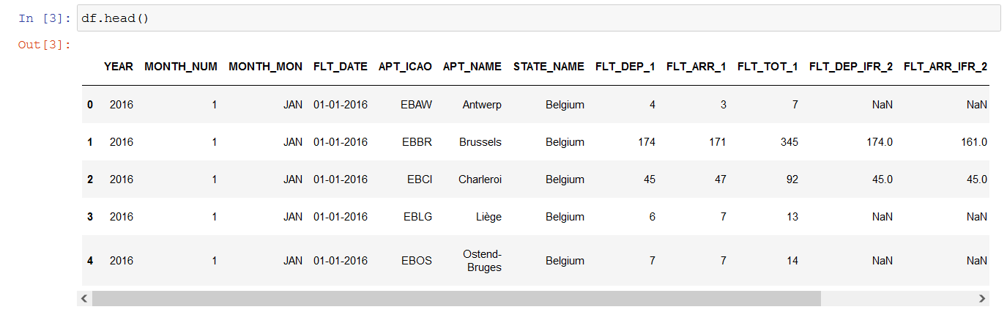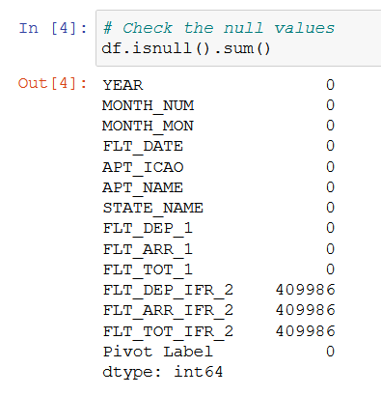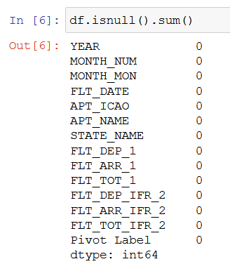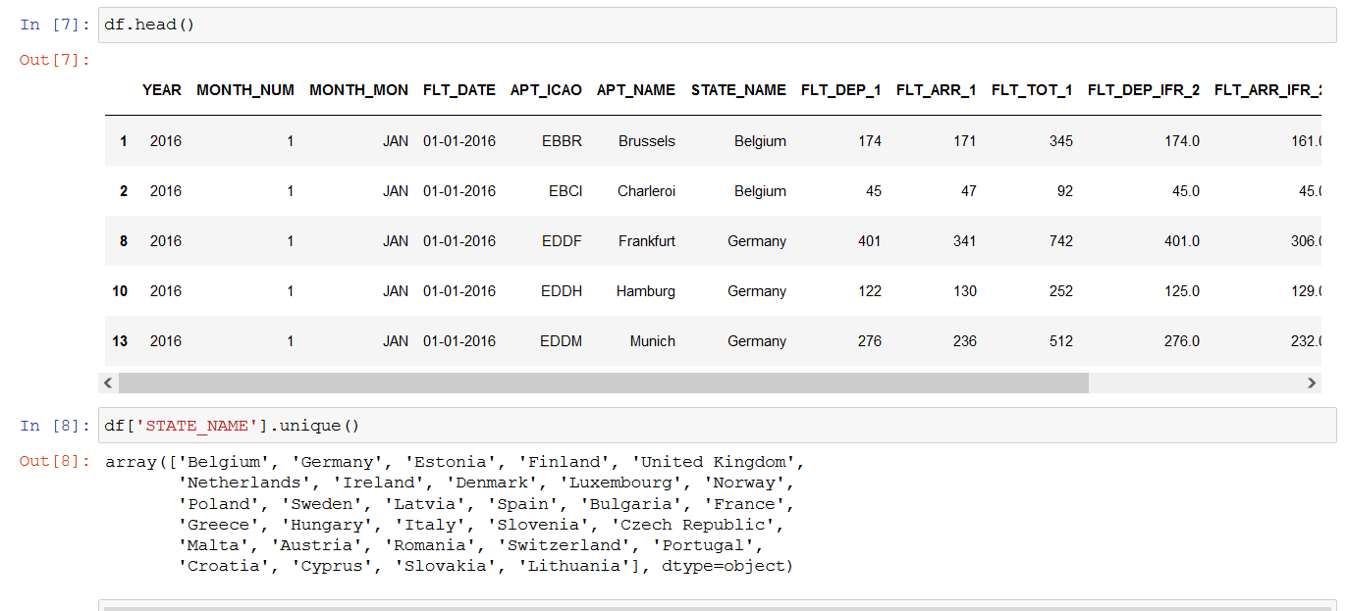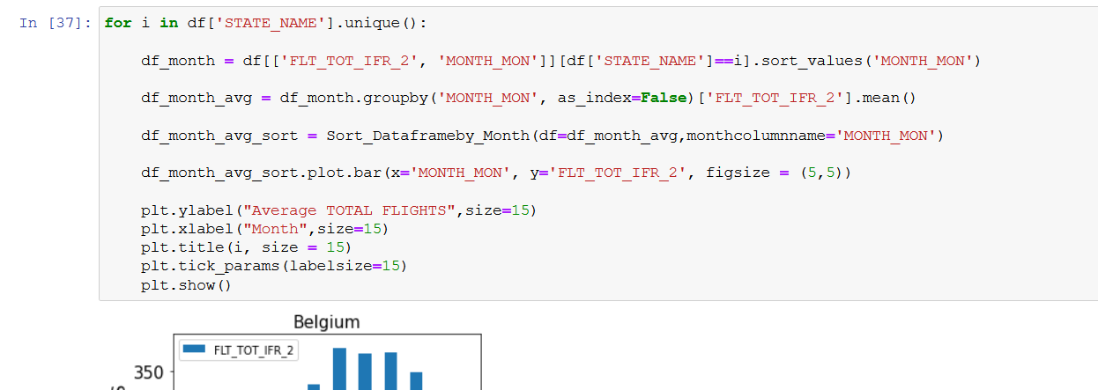

PRE-COVID-29

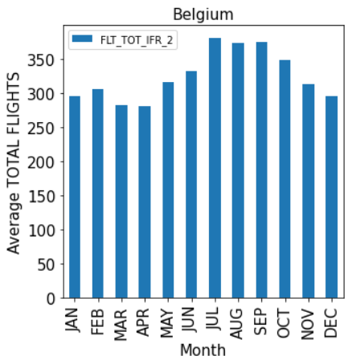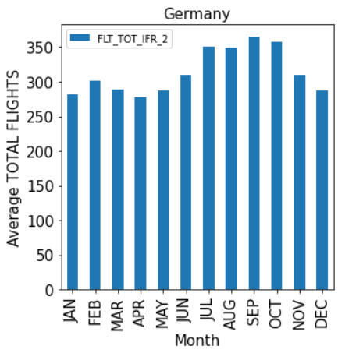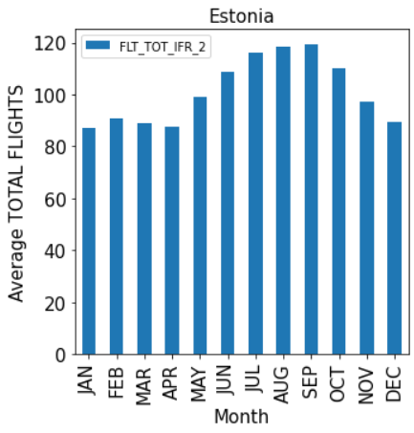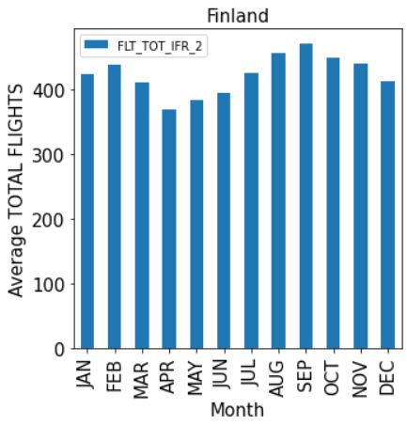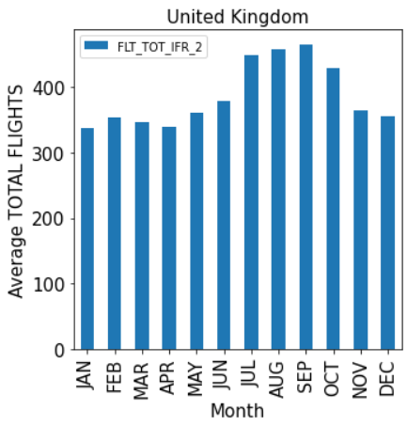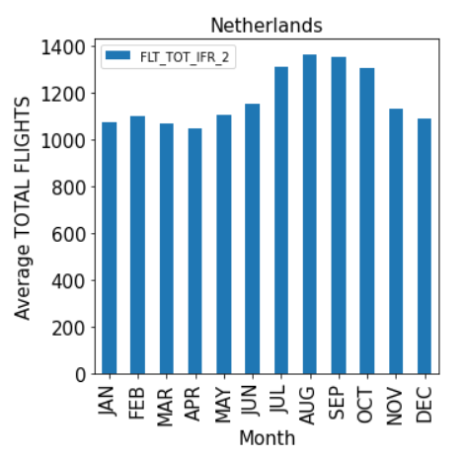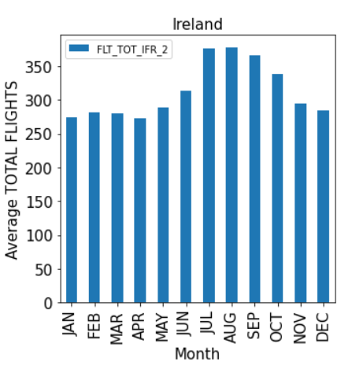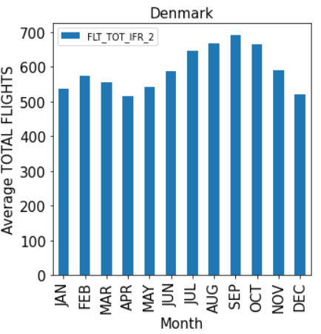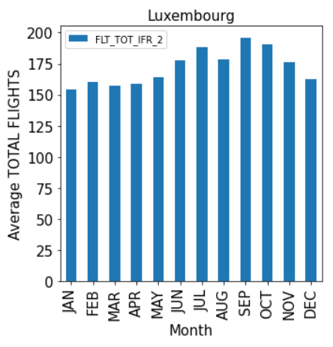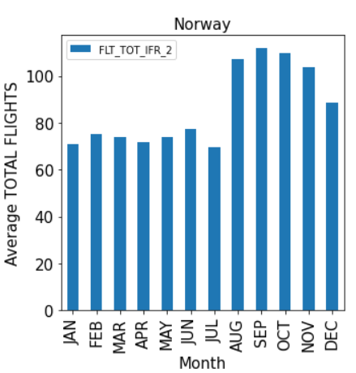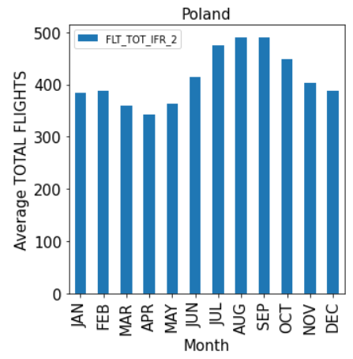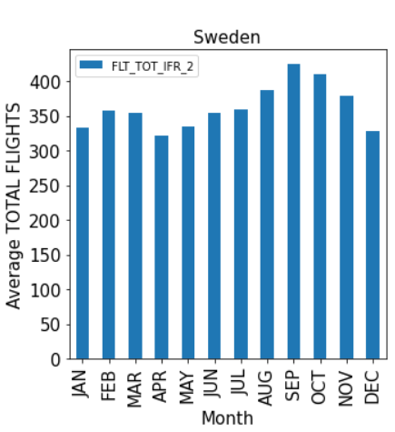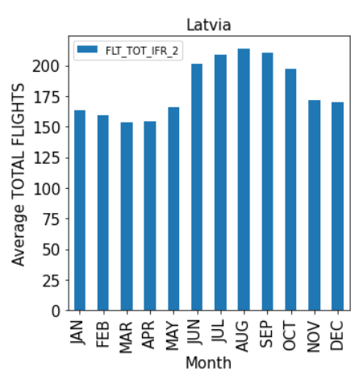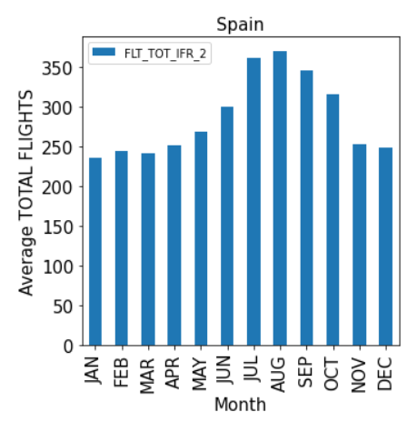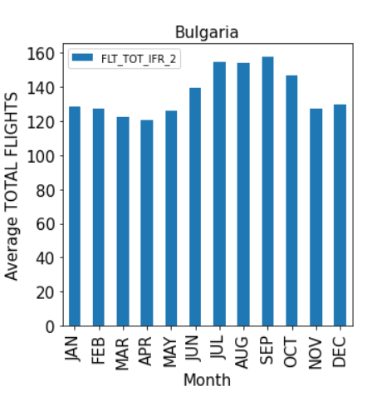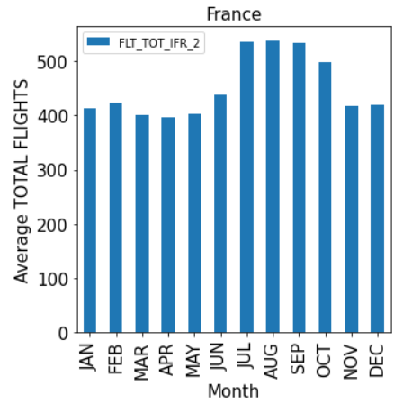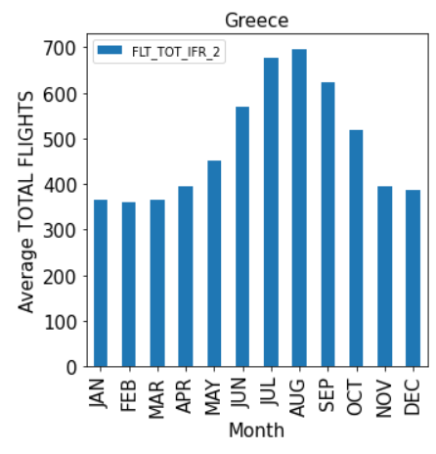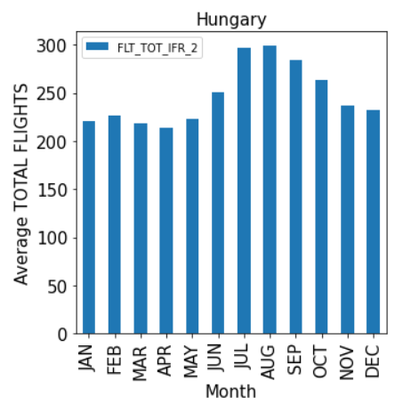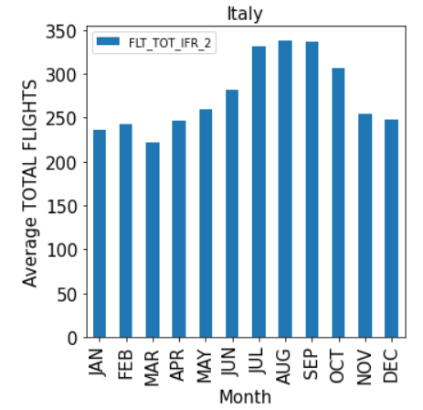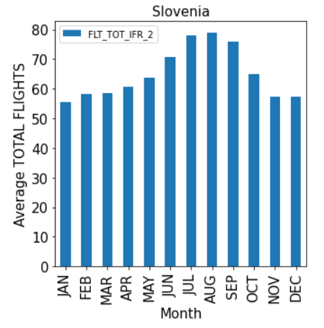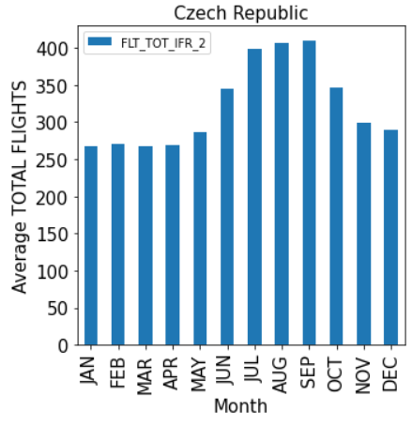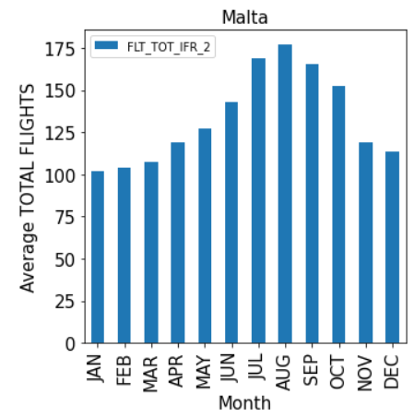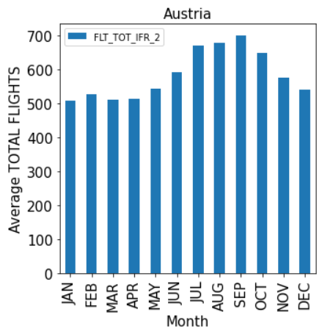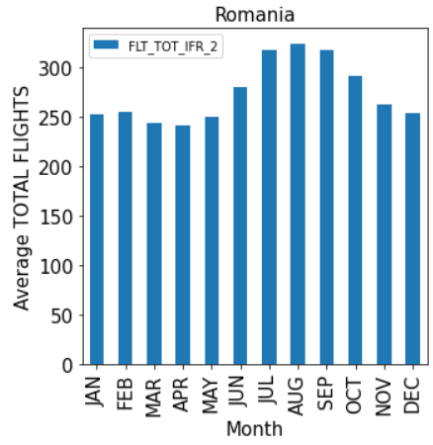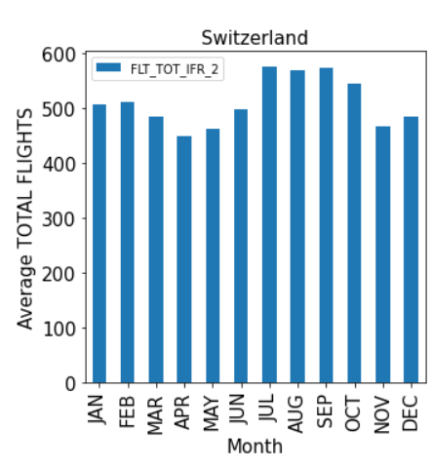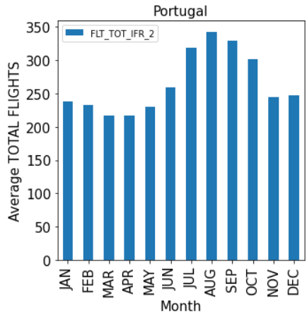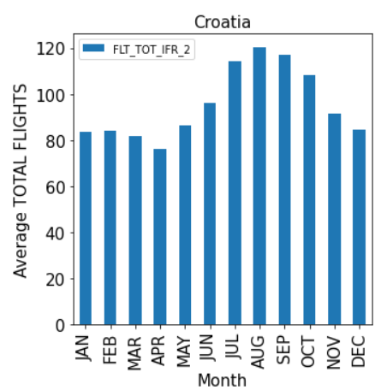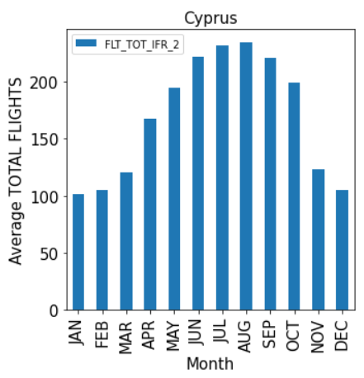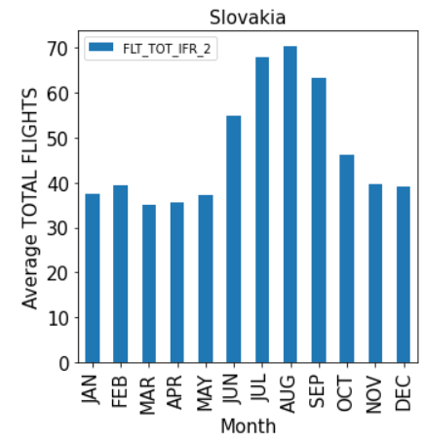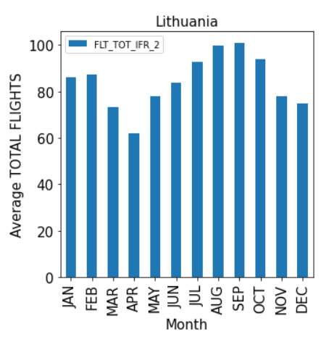

POST-COVID-19

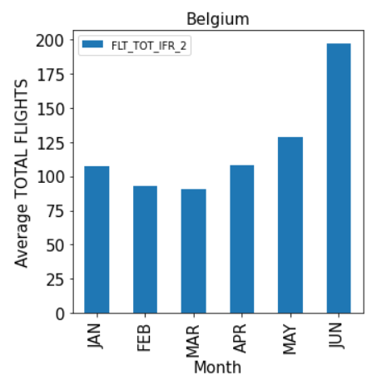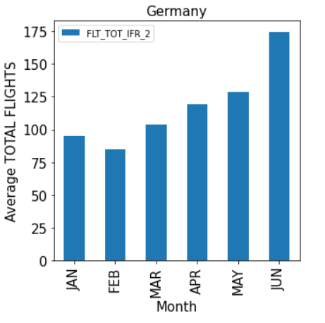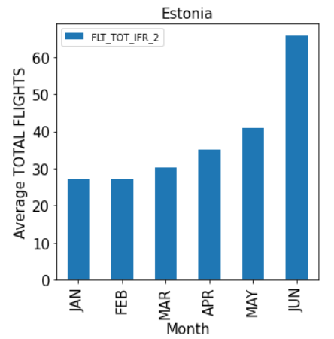

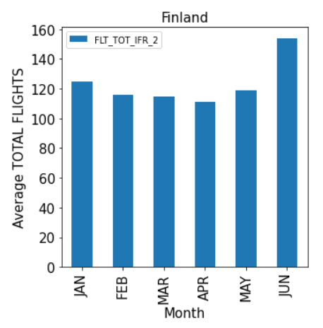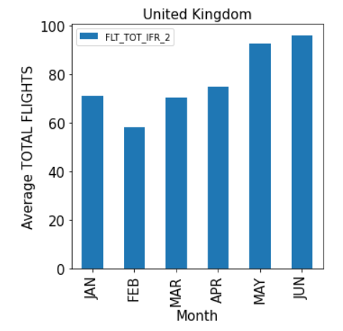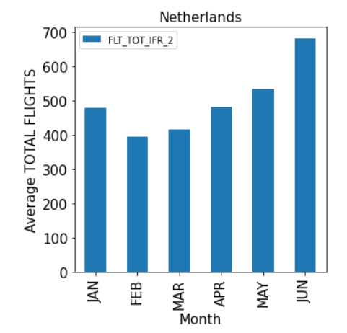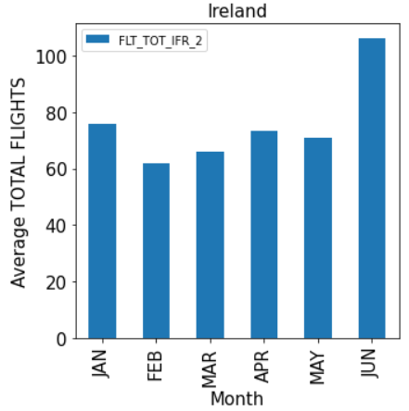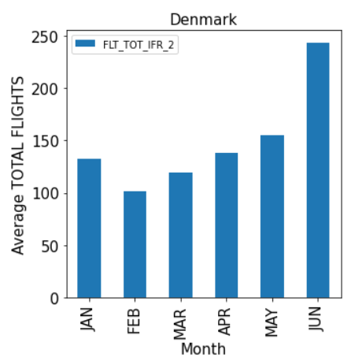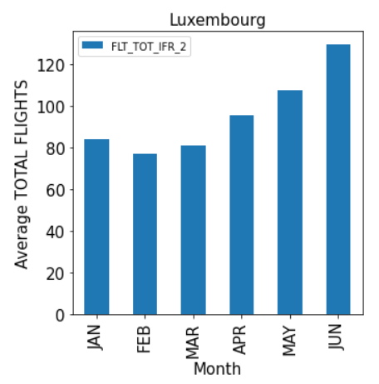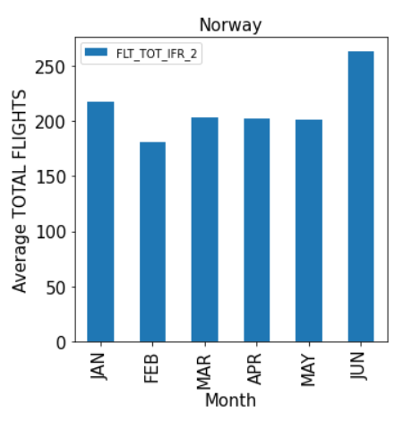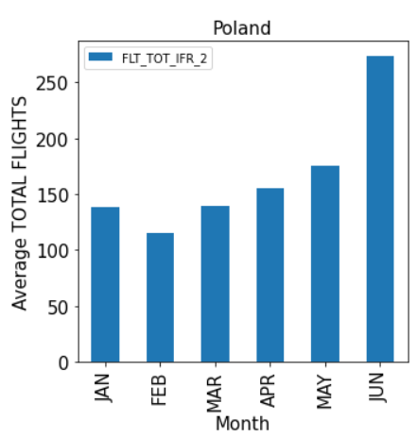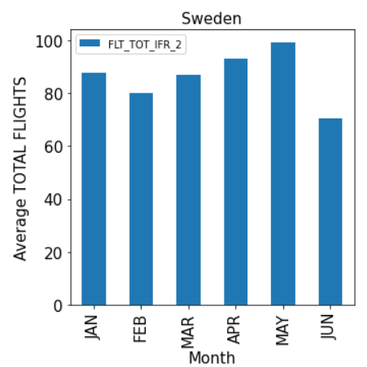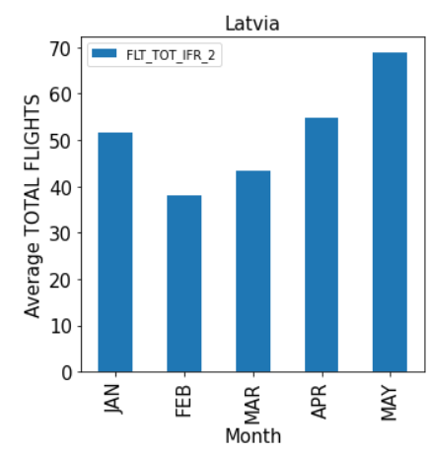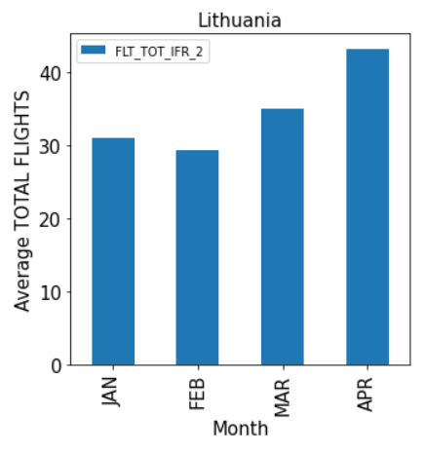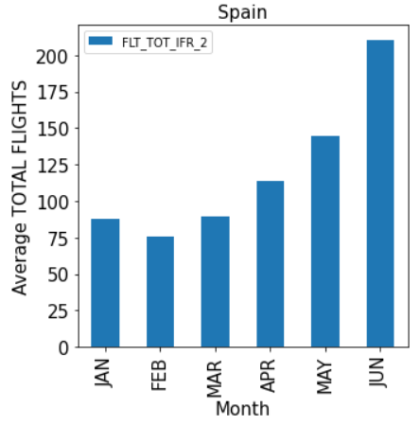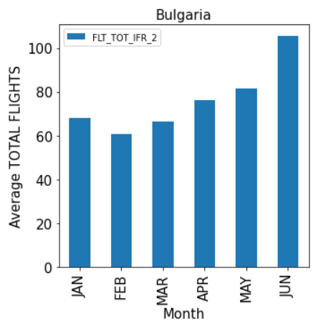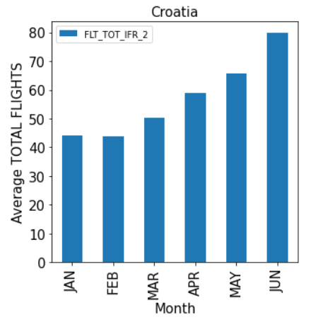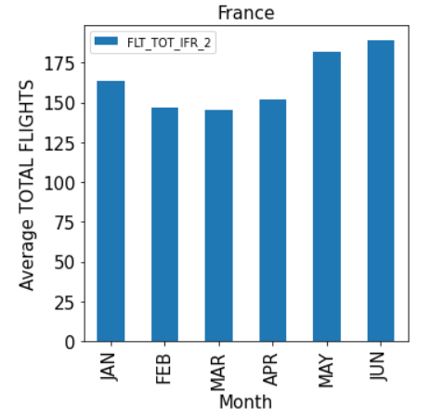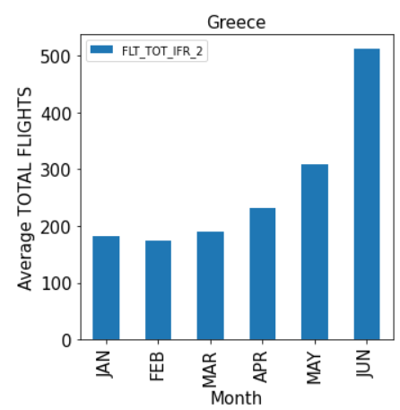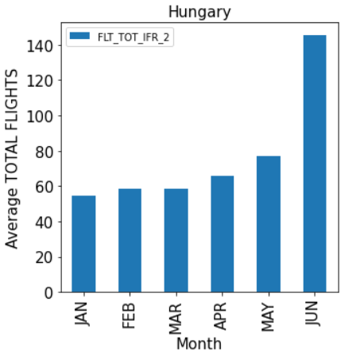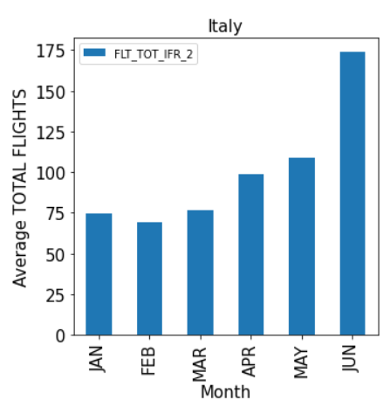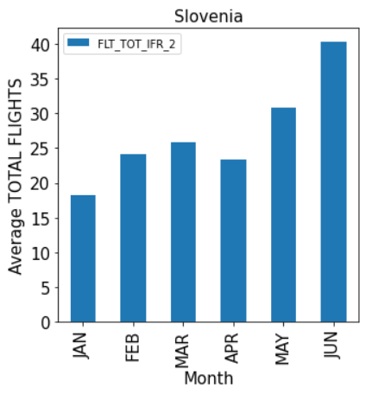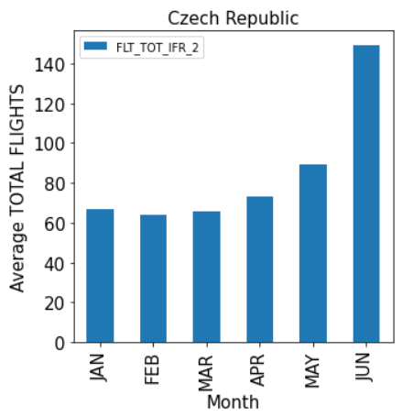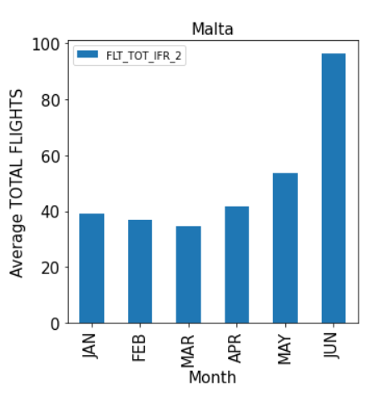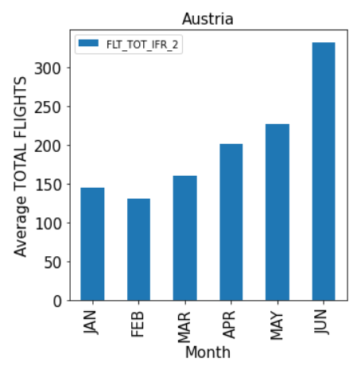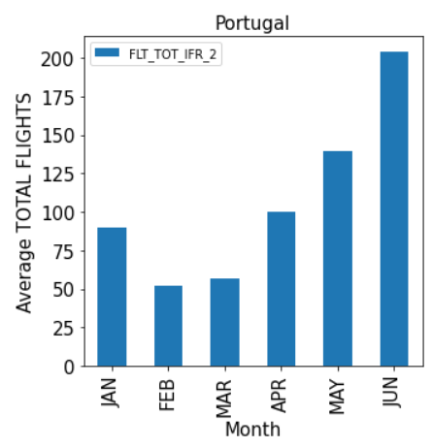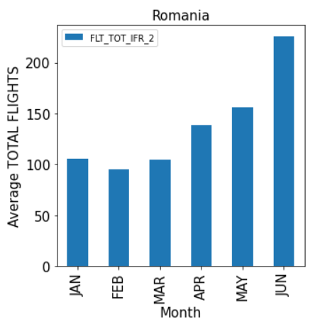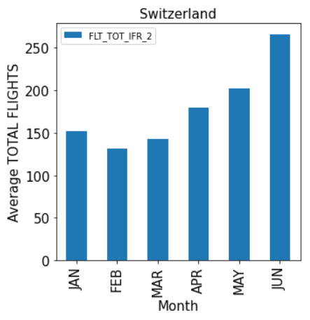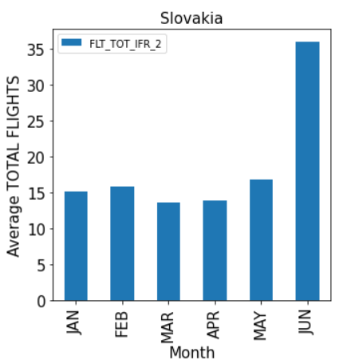

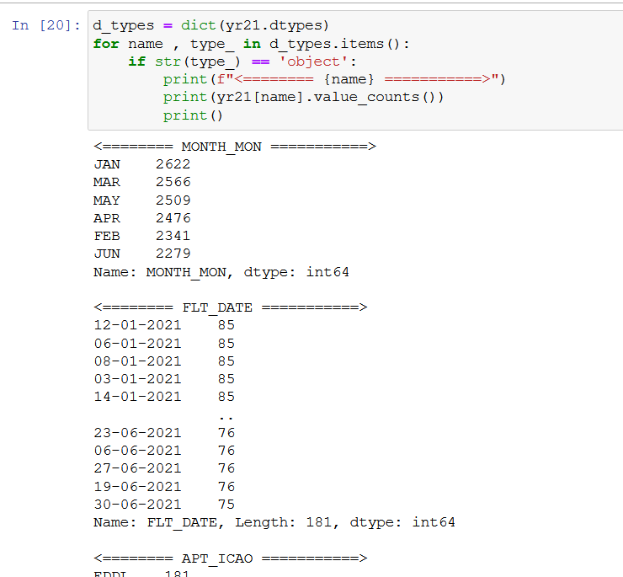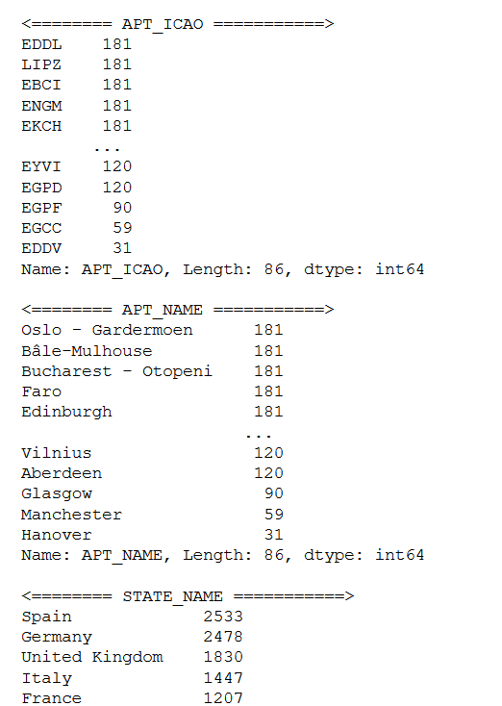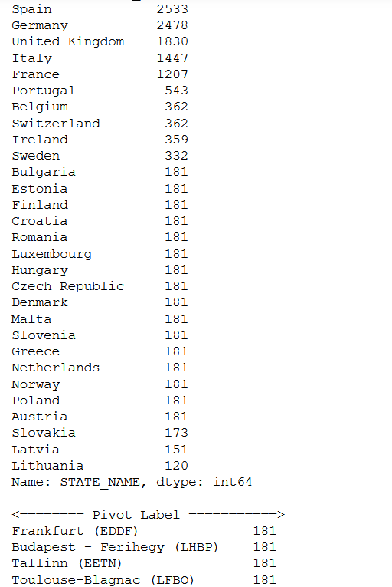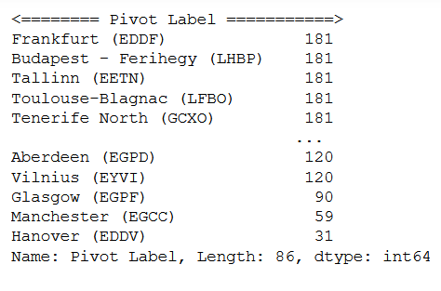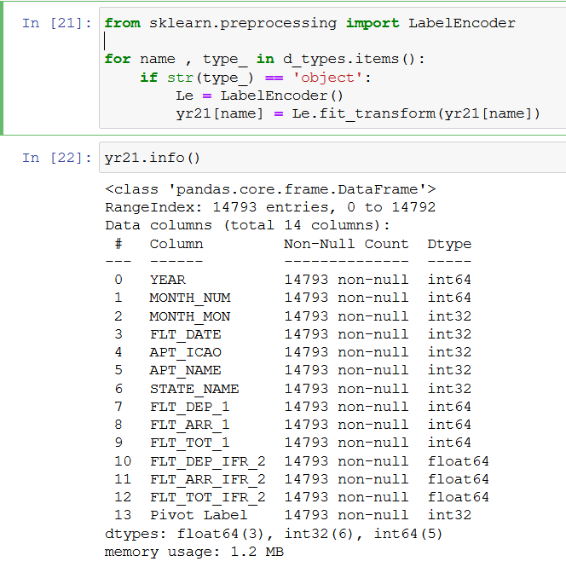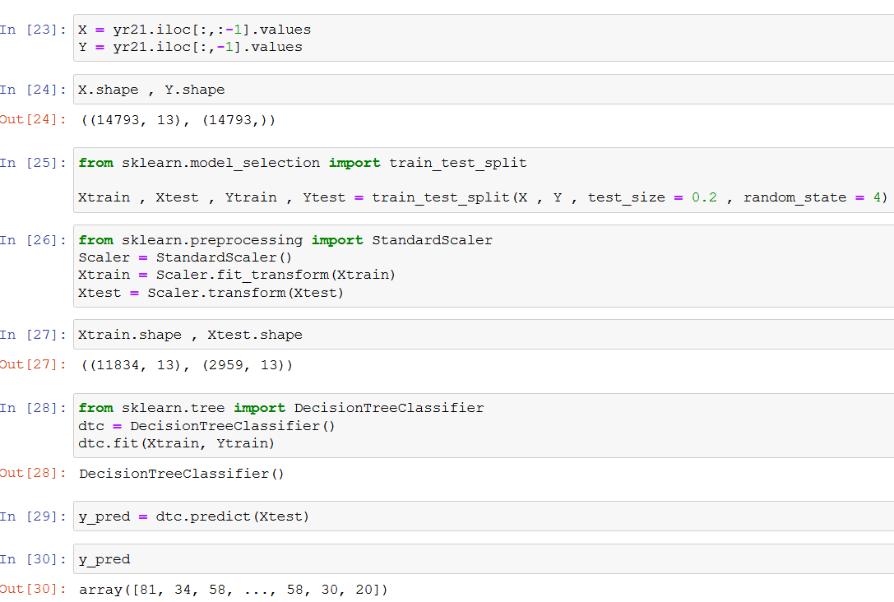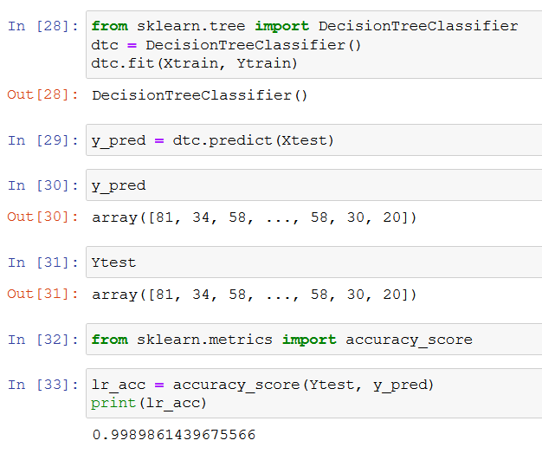

FUTURE SCOPE

The future scope of the project will be that we can use this model to analyze the recent crowd and data, which will help us to make improvements and increase the airport services. Supporting the long-term business is the key in ensuring the survival of the organization. It is advised to transform the organization to cope with quick responses to the demand that arises in the short term. Coordination and cooperation are promoted by strong leadership, which brings great control of the situation. Uncertainty will be one of the main elements affecting airport management and airport operations. The airport operator will therefore have to consider strategies that will maximize the business in the short and long terms. COVID 19 effects on airport design and operations will manifest in particular in the social distancing which will affect airport terminal capacity and level of services provided. Acceleration of biometric technologies deployment will also be needed, which will require improvements to the planning and implementation process.

Finally, airports that remain resilient with sustainable strategies will be able to offer wider variety of goods and services to air travelers. Successful airports will also learn from the current crisis by diversifying and turning to non-passenger revenue to compensate for the decline in air traffic.

CONCLUSION

With the uncertainty brought by COVID19 on the aviation industry, the organizations need to reassess the different scenarios that can occur and ensure that sustainable and safe airport operations can be maintained. Airports will face unpleasant issues caused by the pandemic such as fewer passengers, costly health regulations and airlines and tenants that do not pay their bills on time. For financial sustainability airports should delay non-essential expenditure, stop non-critical recruitment, coordinate with suppliers to find cost saving solutions, reduce or stop not essential contracts, close or scale down non-operational areas and outsource not core services.

We can conclude, that there was a huge impact of COVID-19 on airport traffic. We can see the below image to grasp a better understanding.

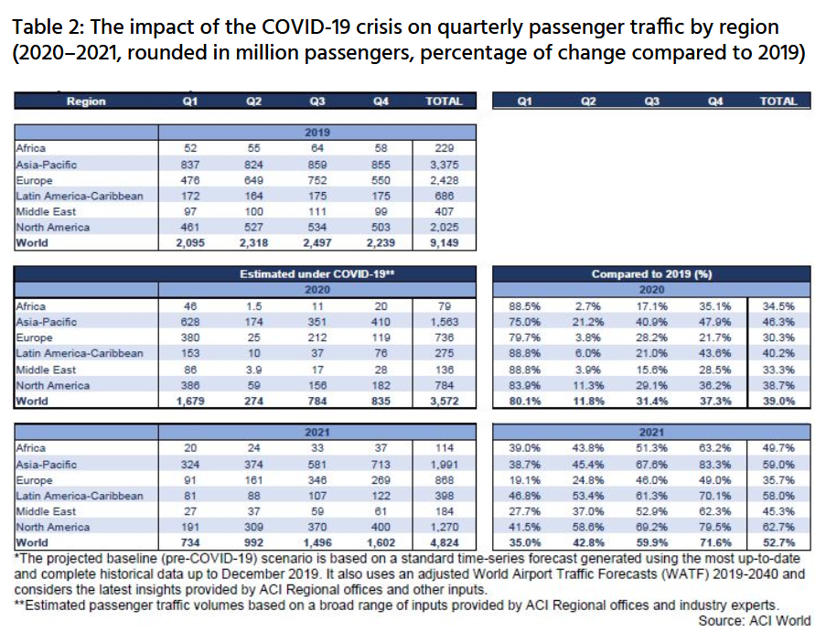

REFERENCES AND BIBLIOGRAPHY

<https://www.kaggle.com/aminianam/airport-traffic-analysis>

<https://www.ncbi.nlm.nih.gov/pmc/articles/PMC7428780/>

<https://aci.aero/news/2021/03/25/the-impact-of-covid-19-on-the-airport-business-and-the-path-to-recovery/>

<https://www.sciencedirect.com/science/article/pii/S2590198220300907>

<https://www.icao.int/sustainability/Pages/Economic-Impacts-of-COVID-19.aspx>

<https://www.kaggle.com/sainiyash/covid-19-s-impact-on-airport-traffic-analysis>

<https://www.ifc.org/wps/wcm/connect/26d83b55-4f7d-47b1-bcf3-01eb996df35a/IFC-Covid19-Airport-FINAL_web3.pdf?MOD=AJPERES&CVID=n8lgpkG>

<https://www.udemy.com/course/machine-learning-data-science-python/learn/lecture/25488602?start=225#overview>

<https://ansperformance.eu/data/>

<https://opensky-network.org/>